CS971 – Computer networks II
Assignment: I
Date: 27th Oct. 2024
Name: P. Sivachandran

Fig_1:
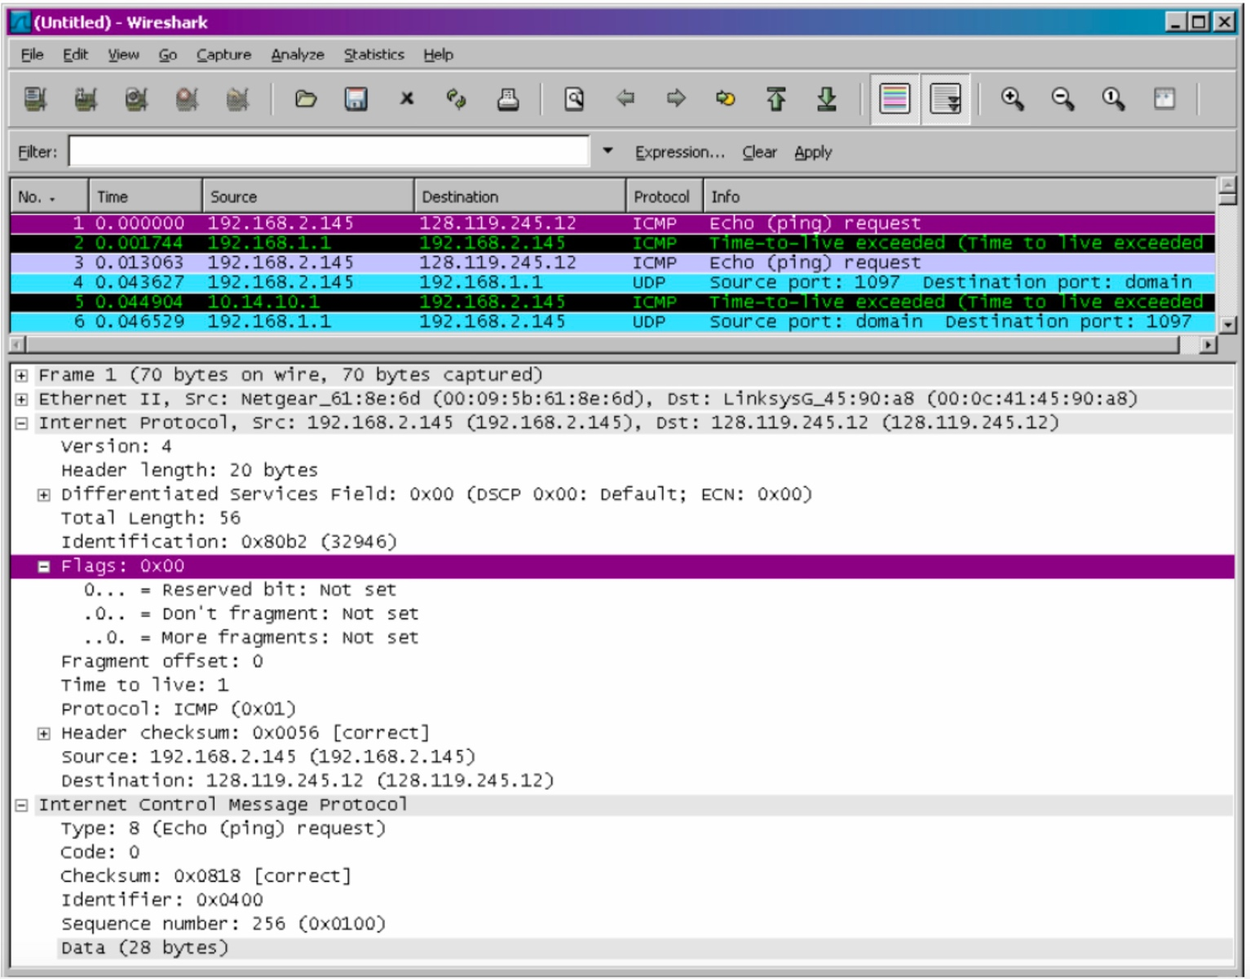

IP Datagram format explanation note captured from lecture video, and just for reference: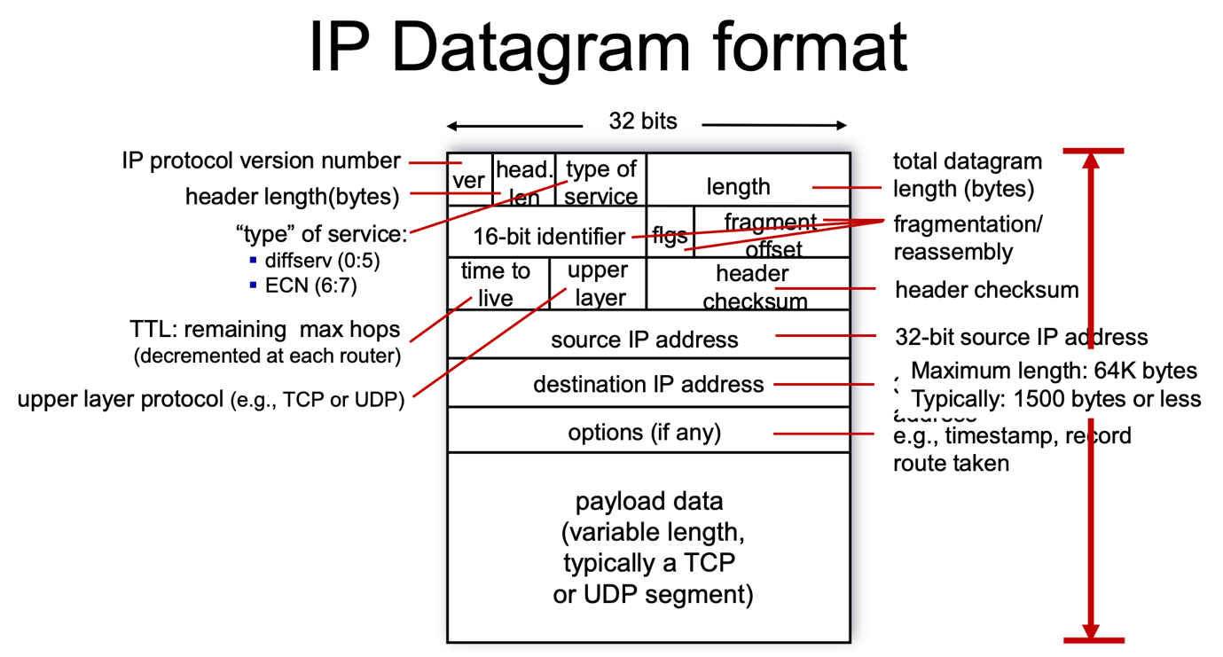

Question – 1: Within the IP packet header, what is the value in the upper layer protocol field?

Ans: “Protocol” field in the above IP header, corresponds to the Protocol type – 1: ICMP

Question – 2: How many bytes are in the IP header? How many bytes are in the payload of the IP datagram? Explain how you determined the number of payload bytes.

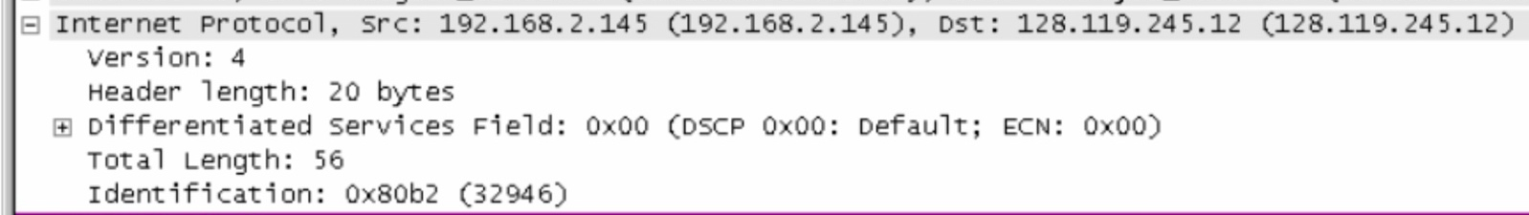

Ans: “Header length” field in the IP header, corresponds to Bytes in IP Header = 20 bytes

Payload bytes = Total length – IP Header length
Payload bytes = 56 – 20 = 36 bytes

Question – 3: Has this IP datagram been fragmented? Explain how you determined whether or not the datagram has been fragmented.

Ans: Refer “More fragments bit of Flags” field in the IP header, accordingly IP datagram is not fragmented
(Since both “Fragment Offset & More fragments” fields are 0)

Additional info:
If “More fragments” filed is 1 it indicates that some more fragment follows
If “More fragments” field is 0, it indicates that either last or single packet
If “Fragment Offset” field is non-zero, indicates that the packet is having fragment

Question – 4: What is the value in the Identification field and the TTL field?

Ans: Refer “Identification” field in the IP header (16 bit), its value is 0x80b2 (32946),
“Time to live” field in the IP header refers to TTL: 1 byte

Fig_2:
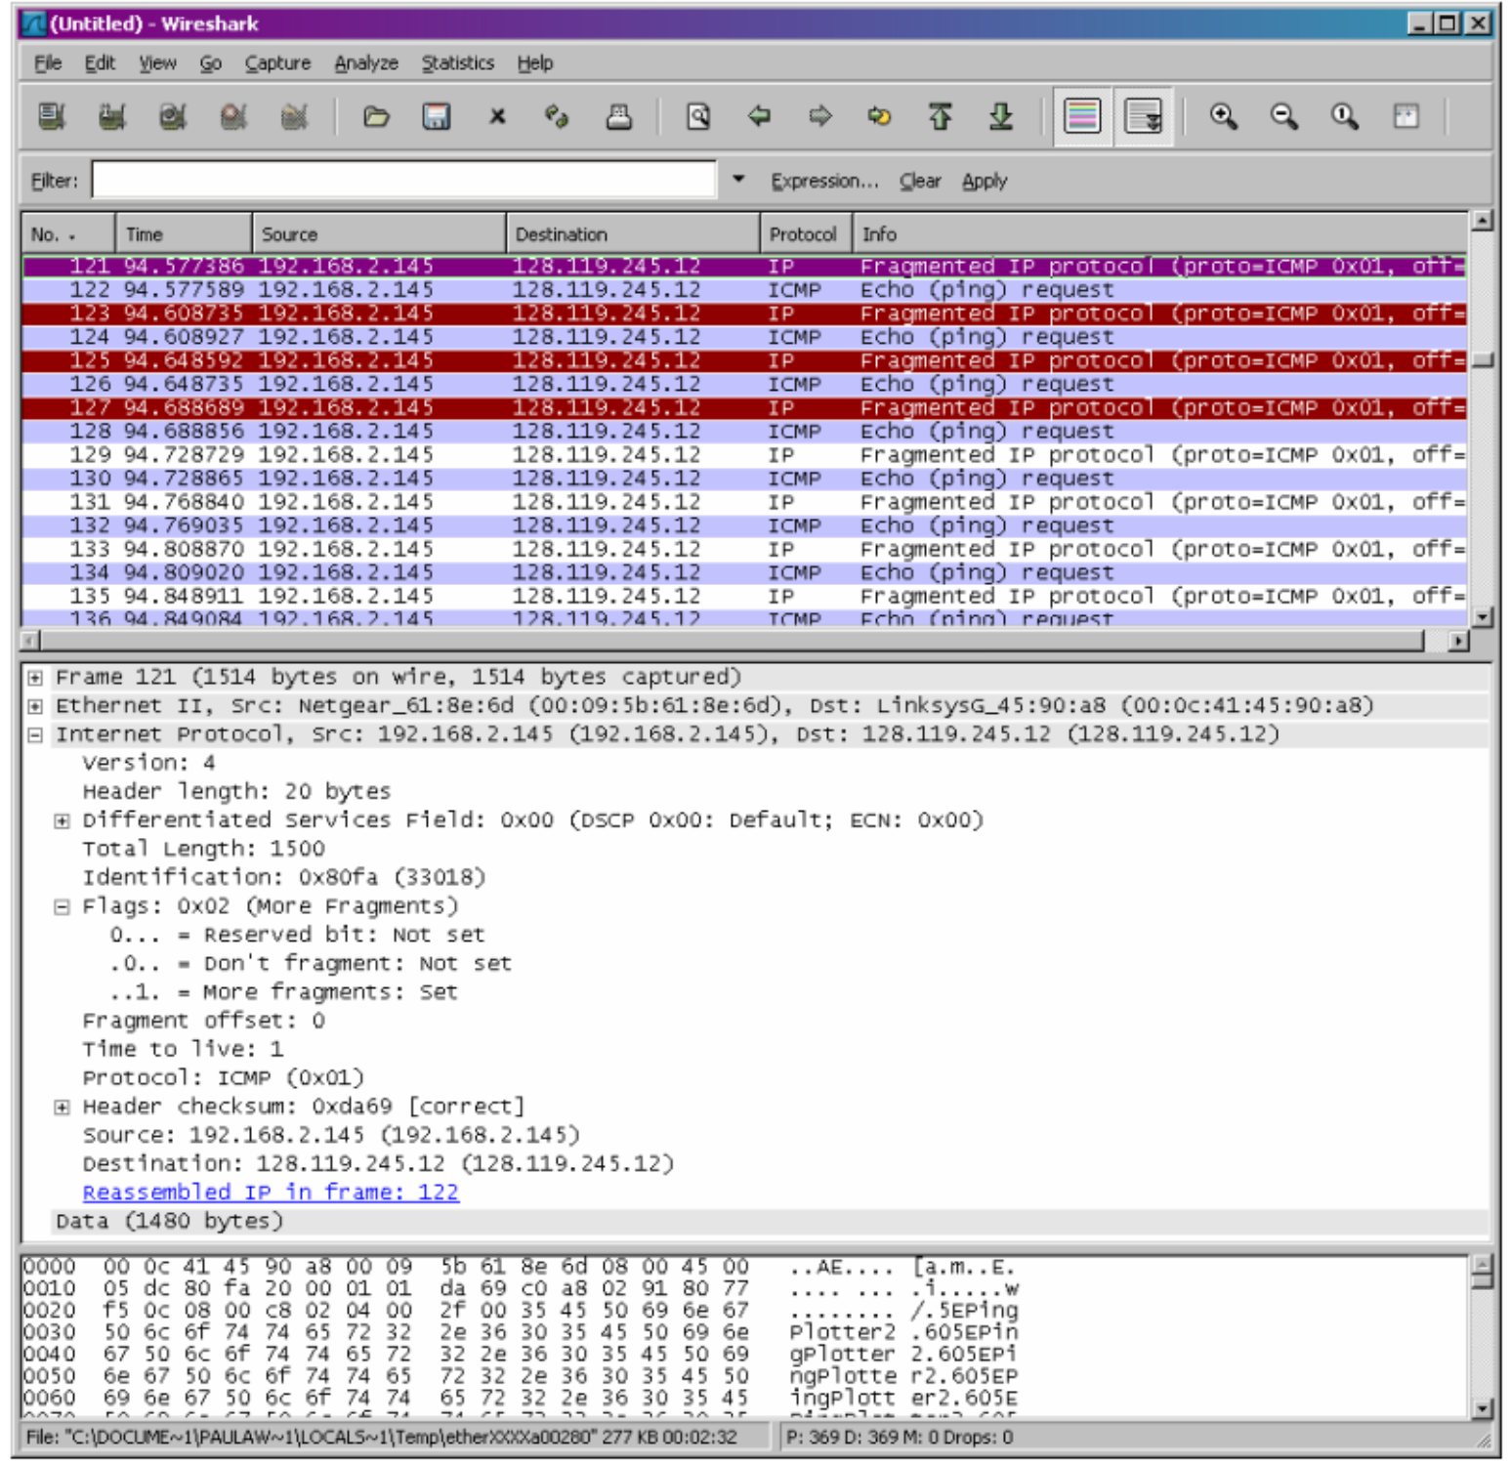

Question_5: Can you say whether the message corresponding to the above packet has been
fragmented?

Ans: Refer “More fragments” field in the above IP header, which is set as “1”, indicates that some more fragments to follow, and the packet is part of fragmented datagram.

Refer “Fragment offset” field in the above IP header (position of this fragment within the original message), which is set as “0”, represents first fragment in the sequence.

Since “Fragment offset (0) & More Fragments (1)”, it confirms that the datagram has been fragmented and this packet represents first fragment.

Question_6: What information in the IP header indicates that the datagram been fragmented?

Ans: MF (More Fragments) – 1, says that fragmented datagram and some more fragments to follow (according to Fragment offset, it refers to first fragment)

Question _7: What information in the IP header indicates whether this is the first fragment versus a latter fragment

Ans: Following status of MF (More Fragments) & Fragment offset, helps to conclude whether the fragment is first or later one.

Fragment offset - 0, helps to identify the first fragment of fragmented datagram (or the only packet exists in the case of not fragmented)

MF - 0, helps to identify this packet is the latter or last fragment (or it will be the only packet exists in the case of “Fragment offset” is 0)

Fig_3:
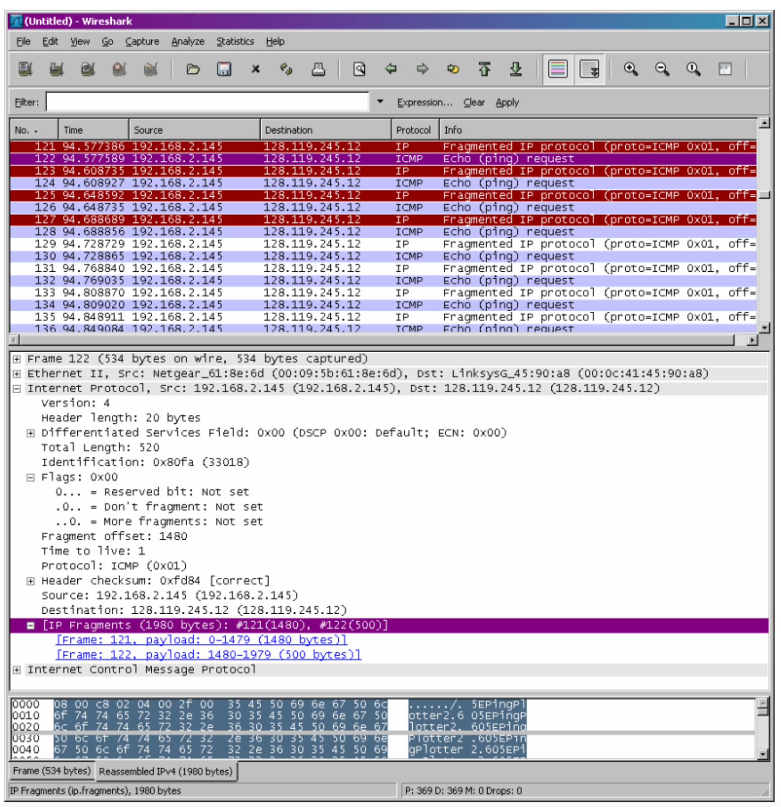

Question_8: What information in the IP header indicates that this is not the first datagram
fragment?

Ans: Since “Fragment offset” field value (1480) is greater than zero, this is not the first fragment of a datagram.

Question_9: Are the more fragments? How can you tell?

Ans: Since “More fragments” field value is zero, there is no more (or last) fragments,

Question_10: If Fig. 2 and Fig. 3 are the 1st and 2nd fragments of a message, then what fields change in the IP header between the first and second fragment?

Fig_2:
Fig_3:
Need to change it as 1

Ans: For the order of 1st and second fragment, need to have following understanding about Fog_2 & Fig_3,

Fig_2: Considered as First fragment
More fragments: set – 1 (No change)
Fragment offset: 0 (No change)

Fig_3: Considered as Second fragment
More fragments: Not set (No change)
Fragment offset: 1 (need to change from 1480 to 1)

